

REACT JS PROJECT REPORT ON
VIRTUAL CLASSROOM DASHBOARD

Submitted by
KELVIN.B
24BIT024

Under the Guidance of
Mr.ARAVIND
Technical Trainer
Technical Department, KG College of Arts and Science

Academic Year: 2025 – 2026
APRIL 2026

DECLARATION
I hereby declare that the project entitled “VIRTUAL CLASSROOM DASHBOARD” submitted in partial fulfillment of the requirements for the course B.SC Information Technology is a record of my original work carried out under the guidance of Aravind, Technical Trainer, Technical Department, KG College of Arts and Science.
I further declare that this project has not been submitted previously, either in part or in full, for the award of any degree, diploma, or other similar title, at this or any other institution.
I have acknowledged all sources of information used in this project wherever applicable.

April 2026
Coimbatore

________________________
KELVIN.B

CERTIFICATE
This is to certify that the project entitled “VIRTUAL CLASSROOM DASHBOARD” is a bona fide work carried out by KELVIN.B [II – B.SC Information Technology/2024], [ Department of Information Technology], KG College of Arts & Science, in partial fulfillment of the requirements for the course [B.SC Information Technology].
This project has been completed under my supervision and guidance during the academic period April 2026.

Place: KG College Of Arts and Science
Date:09/04/2026

Submitted for the Viva-Voce Examination held on 09/04/2026

Guide: Head of the Department
(Technical Trainer, KGCAS) (Technical Head, KGCAS)

Mr.Aravind Mr.Boopalan

TABLE OF CONTENTS
S. No. | Topics | Page. No.
1 | Introduction
1.1 | Background of the Study
1.2 | Problem Statement
1.3 | Objectives of the Project
1.4 | Purpose and Significance
1.5 | Scope and Limitations
1.6 | Methodology Overview
2 | System Analysis
2.1 | Existing System
2.2 | Drawbacks of the Existing System
2.3 | Proposed System
2.4 | Features of the Proposed System
2.5 | Feasibility Study
2.6 | Requirement Analysis
3 | System Design
3.1 | System Architecture
3.2 | Use Case Diagram
3.3 | Data Flow Diagram (DFD)
3.4 | Entity Relationship Diagram (ERD)
3.5 | User Interface Design
4 | System Implementation
4.1 | Development Tools
4.2 | Module Description
4.3 | Algorithms
4.4 | System Integration
4.5 | Security and Validation
5 | System Testing
5.1 | Testing Methodology
5.2 | Test Cases
5.3 | Error Handling
5.4 | Performance
6 | Input and Output Screens
6.1 | System Outputs
6.2 | Discussion
6.3 | Comparison
6.4 | User Feedback
7 | Conclusion and Future Enhancement
7.1 | Summary
7.2 | Limitations
7.3 | Future Scope
8 | References
Appendices
- Source Code Snippets
- Screenshots of Web Pages

ABSTRACT
The Virtual Classroom Dashboard project is a web-based application developed to provide an interactive platform for online teaching and learning. It allows teachers to create and manage classes, assign tasks, and communicate with students, while students can access class details, view assignments, and participate in class discussions through chat.
The system is developed using React.js, CSS, and JavaScript, ensuring a responsive and user-friendly interface. The application uses browser localStorage for storing class and assignment data, making it simple and efficient without requiring a backend.
The main aim of this project is to simplify classroom management and improve interaction between teachers and students in a digital environment. It includes features such as class creation, assignment management, and real-time chat simulation.
This project demonstrates how modern web technologies can be used to build an effective virtual learning environment. It can be further enhanced by adding real-time video classes, database integration, user authentication, and advanced features like notifications and performance tracking.

Chapter 1: Introduction
1.1 Background of the Study
In the modern era, technology has significantly transformed the way education is delivered. Traditional classroom learning is increasingly supported by online platforms that enable remote teaching and learning. A virtual classroom system provides a digital environment where teachers and students can interact, share resources, and manage academic activities from anywhere at any time.
The Virtual Classroom Dashboard is designed as a web-based platform that allows teachers to create and manage classes, assign tasks, and communicate with students, while students can access class details, view assignments, and participate in discussions. Developed using modern web technologies such as React.js, CSS, and JavaScript, this project focuses on providing an interactive and user-friendly interface.
This system helps improve accessibility, organization, and communication in the learning process, making education more flexible and efficient for both teachers and students.

1.2 Problem Statement
Managing online classes and assignments is difficult with existing platforms as they are complex and not user-friendly. Teachers face issues in organizing classes and assignments, and students find it hard to access information and communicate easily.
Hence, a simple and efficient web-based platform is needed to manage classes, assignments, and interaction in one place.

1.3 Objectives of the Project
- To design and develop a simple virtual classroom web application.
- To allow teachers to create classes and assign tasks.
- To enable students to view classes and assignments easily.
- To provide interaction through chat using React.js.

1.4 Purpose and Significance of the Study
The main purpose of this project is to simplify online classroom management through a web-based platform. It helps teachers manage classes and assignments easily, while students can access learning content and interact efficiently.
This system supports digital learning and improves communication between teachers and students in a simple and organized way.
1.5 Scope and Limitations
Scope:
The project focuses on developing the front-end of a virtual classroom system with modules for class management, assignment handling, and chat interaction. It provides a simple interface for teachers and students to access and manage classroom activities.
Limitations:
This version uses localStorage and does not include database connectivity or advanced authentication. Future improvements can include backend integration, real-time video classes, and enhanced security features.

1.6 Methodology Overview
The project follows a basic Software Development Life Cycle (SDLC) approach including Requirement Analysis, Design, Development, Testing, and Implementation.
The application is developed using React.js, JavaScript, and CSS in Visual Studio Code to create an interactive and user-friendly virtual classroom system.

Chapter 2: System Analysis
2.1 Existing System
In the existing system, online classes are conducted using different platforms without a single organized system. Managing classes, assignments, and communication becomes difficult for both teachers and students.
Most systems are complex, lack simple interaction features, and do not provide all classroom activities in one place, reducing efficiency and convenience.
2.2 Drawbacks of the Existing System
- No single platform to manage classes and assignments
- Limited interaction between teachers and students
- Difficult to organize and track classroom activities
- Communication is not efficient
- Existing systems are complex and not user-friendly
2.3 Proposed System
The proposed Virtual Classroom Dashboard provides a centralized and interactive platform for managing online classes. Teachers can create classes, assign tasks, and communicate with students, while students can view class details, check assignments, and participate in chat.
The system is developed using React.js, CSS, and JavaScript to provide a simple and user-friendly interface. It improves classroom management and enhances interaction compared to existing systems.

2.4 Features of the Proposed System
- Simple and user-friendly interface
- Class creation and management by teachers
- Assignment management for each class
- Chat feature for teacher-student interaction
- Can be extended with database, video classes, and advanced features

2.5 Feasibility Study
Technical Feasibility:
The project uses React.js, JavaScript, and CSS, which are easy to develop and support all modern browsers.
Economic Feasibility:
The development cost is low as it uses free tools and does not require paid software or hosting.
Operational Feasibility:
The system is simple and user-friendly, so both teachers and students can use it easily without any special training.

2.6 Requirement Analysis
Functional Requirements:
- Users can login as teacher or student
- Teachers can create classes and add assignments
- Students can view classes and assignments
- Chat feature for communication
- Dynamic display of class details
Non-Functional Requirements:
- Fast and responsive performance
- Simple and user-friendly interface
- Data stored using localStorage
- Easy to maintain and extend in future

Chapter 3: System Design
3.1 Introduction
System design defines the overall structure and working of the application. It converts the requirements into a clear plan for development.
For the Virtual Classroom Dashboard, the design focuses on the interaction between users (teachers and students), different modules like classes and assignments, and data handling using localStorage to manage classroom activities effectively.

3.2 System Architecture
The system follows a simple three-layer architecture — Presentation Layer (Frontend), Application Logic Layer, and Data Layer.

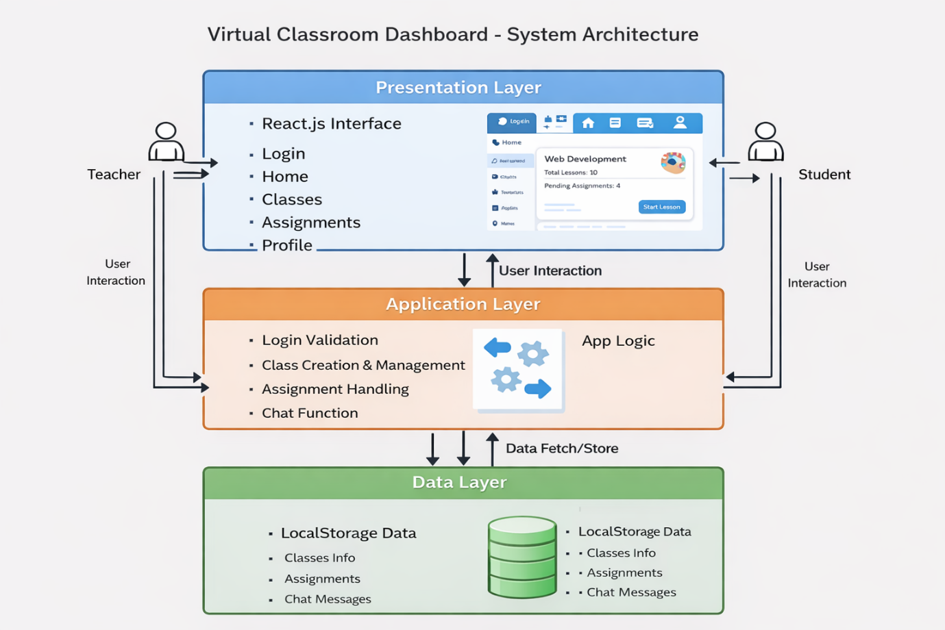
Description:
• Presentation Layer: Handles user interface using React.js and displays pages like Login, Home, Classes, Assignments, and Profile.
• Application Layer: Manages application logic such as login validation, class creation, assignment handling, and chat functionality.
• Data Layer: Stores and retrieves data using browser localStorage for classes, assignments, and chat messages.

3.3 Use Case Diagram
1. What is a Use Case Diagram?
Use Case Diagram shows how users interact with the system. It includes:
- Actors: Teacher and Student
- Use Cases: Actions like login, view classes, add assignments, and chat
- Relationships: Shows how users perform actions in the system
It helps to clearly explain “who does what” in the Virtual Classroom Dashboard.

2. Identify the Main Actors (for your Educational Website)
Actor | Description
Teacher | Creates classes, adds assignments, and interacts with students through chat
Student | Views classes, checks assignments, and participates in chat
Guest(optional) | Can view limited content without logging in

3. Identify the Main Use Cases
For Teacher
- Login
- Create Classes
- Add Assignments
- View Classes
- Chat with Students
For Student
- Login
- View Classes
- View Assignments
- Participate in Chat

4. Define Relationships
Symbol | Meaning
Solid line | Association (Actor performs a use case)
<<include>> | A required action inside another use case
<<extend>> | An optional action based on condition
Example:
- “Add Assignment” <<include>> “Select Class”
- “View Assignments” <<extend>> “View Classes”

5. Draw the Diagram (Structure Example)
Tools you can use:
- draw.io (free online)
- Lucidchart
- StarUML
- MS Visio
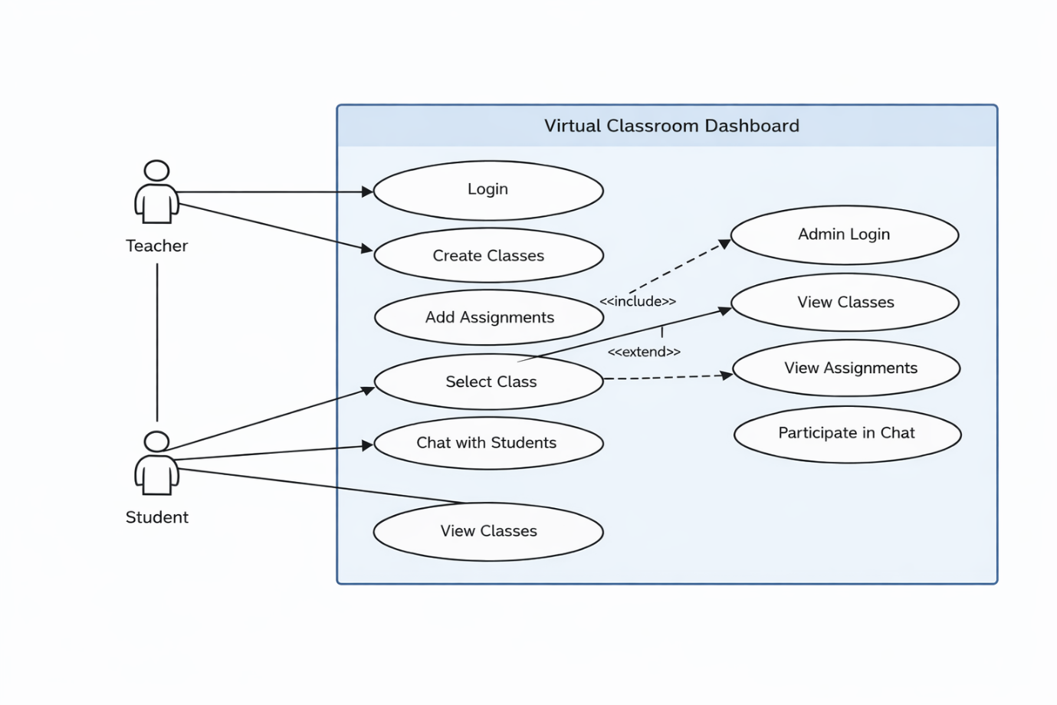

6. Example Explanation (Text Description)
Actors:
- Teacher: Manages classes, assignments, and interacts with students
- Student: Views classes, checks assignments, and participates in chat
Use Cases:
- Login: User logs into the system
- Create Class: Teacher creates new classes
- Add Assignment: Teacher adds assignments to a class
- View Classes: Student views available classes
- View Assignments: Student checks assignments
- Chat: Teacher and student communicate
Relationships:
- “Add Assignment” <<include>> “Select Class”
- “View Assignments” <<extend>> “View Classes”

7. Step-by-Step (Using draw.io)
- Go to https://app.diagrams.net
- Choose a blank diagram → name it “Use Case Diagram – Virtual Classroom Dashboard”
- From the left panel, drag:
- Stick figures → Teacher, Student (Actors)
- Ovals → Login, Create Class, Add Assignment, View Classes, Chat
- Rectangle → system boundary (Virtual Classroom Dashboard)
- Connect Actors ↔ Use Cases using lines
- Add relationships (<<include>> / <<extend>>) where needed
- Export as .PNG / .JPG and insert into your documentation
3.4 Data Flow Diagram (DFD)
1. What is a Data Flow Diagram (DFD)?
A Data Flow Diagram shows how data moves through the system —
from input → processing → storage → output.
It helps to understand:
- Where data comes from (Teacher/Student)
- How it is processed (login, class, assignment, chat)
- Where it is stored (localStorage)
- How it is used and displayed in the system

2. DFD Symbols You’ll Use
Symbol | Meaning
Rectangle | External Entity (e.g., Student, Teacher)
Circle / Rounded Rectangle | Process (Login,Manage Classes,Add Assignment,Chat)
Two Parallel Lines | Data Store (Classes Data,Assignment Data ,Chat Data in localStorage)
Arrow | Data Flow (shows movement of data between components)

3. Levels of DFD
Level 0 — Context Diagram (Top Level)
Shows the entire Virtual Classroom Dashboard as a single process interacting with Teacher and Student.
Level 1 — Decomposition
Breaks the system into processes like Login, Manage Classes, Assignments, and Chat.
Level 2 — Detailed Level
Further explains each process in detail (optional for this project).

4. Steps to Create a DFD
Step 1: Identify External Entities
- Teacher
- Student
- System (Virtual Classroom Dashboard)
Step 2: Identify Main Processes
- Login Validation
- Manage Classes
- Add Assignments
- View Classes & Assignments
- Chat Process
Step 3: Identify Data Stores
- Classes Data (localStorage)
- Assignments Data
- Chat Data
Step 4: Identify Data Flows
- “Login Request / Response”
- “Class Details”
- “Assignment Data”
- “Chat Messages”

5. DFD for Educational Website
Level 0: Context Diagram
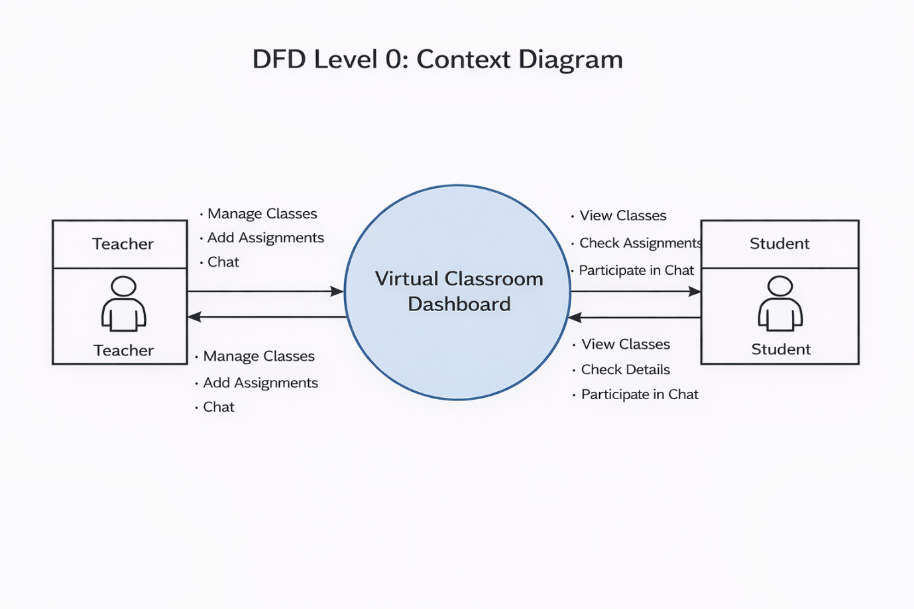
Explanation:
- Teacher interacts with the system to create classes, add assignments, and communicate with students.
- Student interacts with the system to view classes, check assignments, and participate in chat.
- The system processes all inputs and displays the required information.

Level 1: Detailed System View
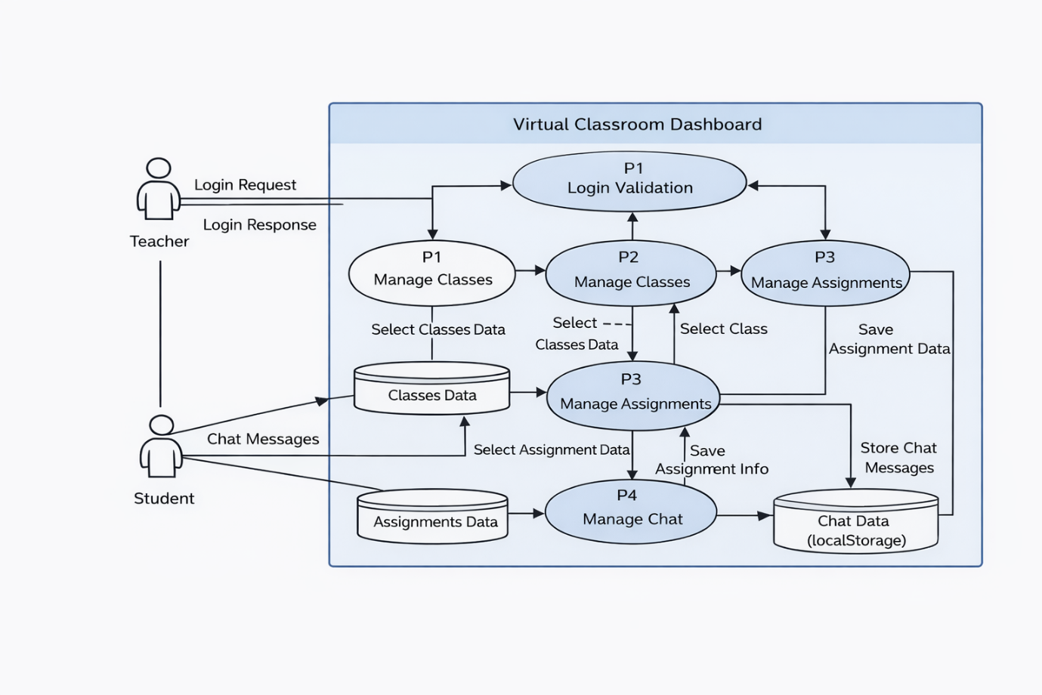
Explanation:
- Process P1: Handles login validation and user authentication
- Process P2: Manages classes (create, view, select classes)
- Process P3: Handles assignments (add and view assignments)
- Process P4: Manages chat messages between teacher and students
Level 2: Detailed Process (Assignment & Chat Process)

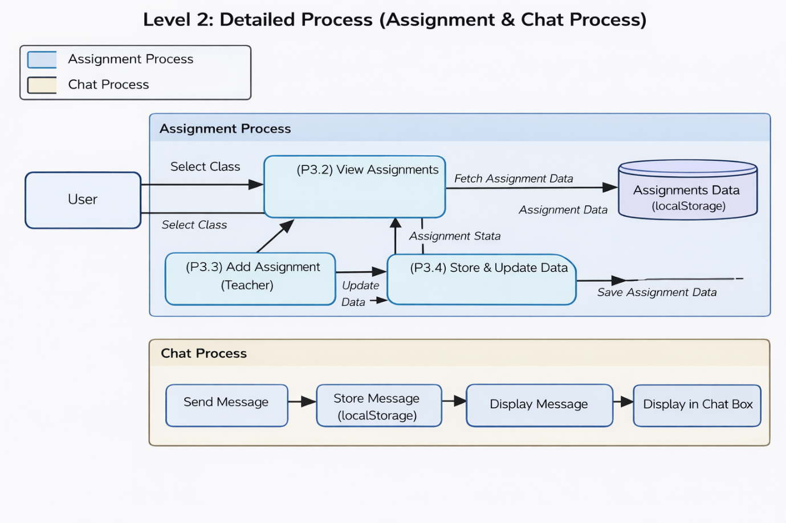

6. Tools to Draw Your DFD
Free, easy online tools:
- https://app.diagrams.net (recommended)
- Lucidchart
- Creately
- StarUML
- Microsoft Visio
Steps (in draw.io):
- Go to https://app.diagrams.net
- Choose Blank Diagram → name it “DFD_VirtualClassroomDashboard”
- Use shapes:
  - Rounded rectangle → Processes (Login, Classes, Assignment, Chat)
  - Parallel lines → Data Store (localStorage data)
  - Rectangle → External Entities (Teacher, Student)
  - Arrows → Data Flow
- Label all arrows clearly (e.g., Login Data, Assignment Data, Chat Message)
- Export as .PNG / .JPG and add to your documentation

3.5 Entity Relationship Diagram (ERD)
Entities and Attributes:
- Class (Class_ID, Class_Name, Teacher, Time, Status)
- Assignment (Assignment_ID, Class_ID, Topic)
- User (Username, Role)
- Chat (Message_ID, Class_ID, User, Message)
Relationships:
- A Teacher can create multiple Classes
- A Class can have many Assignments
- A Class can have many Chat Messages
- Students can view classes and participate in chat
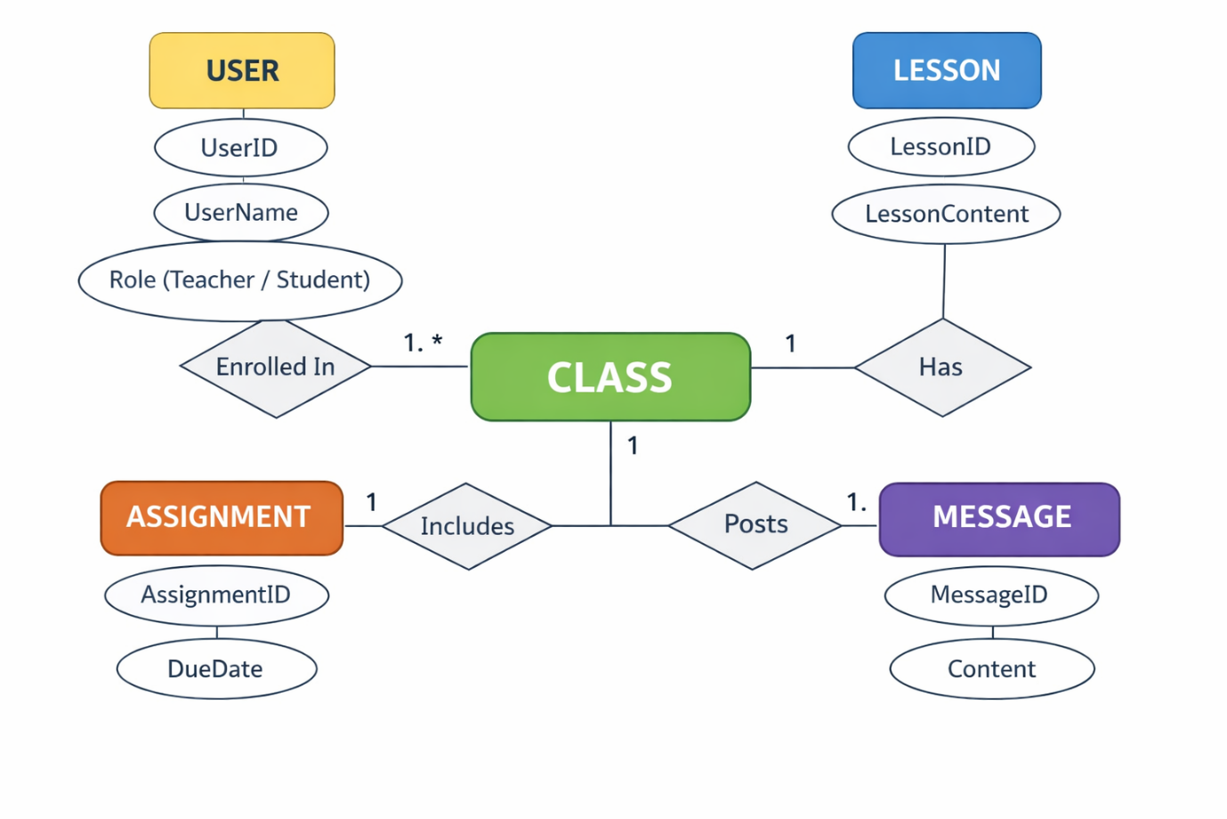
3.6 User Interface Design
The UI is designed to be simple, responsive, and user-friendly. It uses React.js, CSS for styling, and JavaScript for interactivity.
Main Pages:
- Login Page:
Allows users to login as Teacher or Student
- Home Page:
Displays welcome message and basic navigation
- Classes Page:
Shows list of classes, allows teachers to create classes, and students to view them
- Assignments Page:
Displays assignments for selected class
- Profile Page:
Shows user details like username and role

Chapter 4: System Implementation
4.1 Introduction
System implementation is the stage where the design is converted into a working application. This phase includes coding, integrating different modules, testing features, and ensuring the system works properly.
The Virtual Classroom Dashboard is implemented using React.js, JavaScript, and CSS, providing an interactive and responsive platform for managing classes, assignments, and communication.

4.2 Development Tools and Technologies
Module | Purpose
React.js | Builds the user interface using components
CSS3 | Adds styling and responsive design
JavaScript (ES6) | Handles logic like login, classes, assignments, and chat
Visual Studio Code | Code editor for development
Browser (Chrome / Edge) | Used to run and test the application.
LocalStorage / JSON | Stores classes, assignments, and chat data locally

4.3 System Modules Description
Module | Description
Login Module | Allows users to login as Teacher or Student
Home Module | Displays welcome message and navigation options
Classes Module | Shows classes, allows teachers to create and manage classes
Assignment Module | Teachers add assignments, students can view them
Chat Module | Enables communication between teacher and students
Profile Module | Displays user details like username and role
Each module is interconnected through JavaScript functions, ensuring smooth navigation and state management within the website.

4.4 Implementation Details
The implementation follows a modular approach:
- Frontend Design:
The user interface is built using React.js and styled with CSS for a clean and responsive layout.
- Dynamic Behavior:
JavaScript (React state) is used to dynamically update classes, assignments, and chat messages.
- Event Handling:
User actions like login, adding classes, assignments, and sending messages are handled using event handlers (onClick, onChange).
- Application Logic:
Handles login validation, class management, assignment updates, and chat functionality in real-time.
- Data Management:
Data such as classes, assignments, and chat messages are stored and retrieved using localStorage.

4.5 Algorithm / Logic of Core Function
Algorithm for Login Validation:
- Enter username and password
- Check in teacher and student data
- If match found → allow login
- Else → show error message
Algorithm for Class Management:
- Enter new class name
- Create class object
- Add to class list
- Update and display classes
Algorithm for Assignment Handling:
- Select a class
- Enter assignment topic
- Add assignment to selected class
- Update and display assignments
Algorithm for Chat Function:
- Enter message
- Add message to selected class chat
- Store in localStorage
- Display updated messages

4.6 Security and Validation
- Input validation is used to prevent empty fields during login, class creation, assignment, and chat
- Only valid user inputs are processed in the system
- Data is stored locally using localStorage (no external data sharing)
- Basic error handling is implemented using alerts and conditional checks
4.7 Integration
All modules are integrated using React and event-driven programming. Navigation between pages like Home, Classes, Assignments, and Profile is handled using state management, ensuring smooth transitions without reloading the page.
4.8 Output Screens (Snapshots)
Include labeled screenshots for the following pages:
- Login Page – User login interface (Teacher/Student)
- Home Page – Welcome message and navigation
- Classes Page – List of classes and class details
- Assignments Page – Display of assignments for selected class
- Profile Page – User information (username and role)

Chapter 5: System Testing
5.1 Introduction
System testing ensures that the application works correctly and meets all requirements. It checks whether all features function properly under different conditions.
For the Virtual Classroom Dashboard, testing is done to verify modules like login, class management, assignment handling, and chat functionality.

5.2 Objectives of Testing
- To ensure all modules (Login, Classes, Assignments, Chat, Profile) work correctly
- To identify and fix errors in the system
- To verify that user inputs produce correct outputs
- To ensure the application works smoothly on different browsers and devices

5.3 Types of Testing Performed
a) Unit Testing
Each function like login validation, class creation, assignment addition, and chat handling was tested individually.
b) Integration Testing
All modules were combined and tested to ensure smooth navigation between Home, Classes, Assignments, and Profile pages.
c) System Testing
The complete application was tested to verify all features like login, class management, assignments, and chat work properly.
d) User Acceptance Testing (UAT)
Tested with users to check usability, design, and performance; feedback was considered for improvements.
e) Cross-Browser and Device Testing
Tested on browsers like Chrome and Edge, and devices like laptops and mobiles to ensure responsiveness.

5.4 Test Plan
Test ID | Module | Test Description | Type | Expected Output | Status
T01 | Login | Valiate uder credentials | Functional | User logged in successfully | Pass
T02 | Classes | Display all classes | Functional | Class cards visible | Pass
T03 | Assignment | Add and view assignment | Logic | Assignment displayed correctly | Pass
T04 | Chat | Send and display messages | Function | Message appears in chat box | Pass
T05 | Navigation | Move between pages | Integration | Smooth page transition | Pass
T06 | Input Validation | Submit empty field | Validation | Error message shown | Pass
T07 | Responsiveness | View on mobile devices | UI | Layout adjusts properly | Pass
T08 | Storage | Save data in localStorage | Data | Data perists after refresh | Pass

5.5 Test Data and Execution
Sample data were created for users, classes, assignments, and chat messages. The application functions were tested to ensure correct data storage and retrieval using localStorage.
The output was verified by comparing expected results (like class display, assignment list, and chat messages) with actual results.

5.6 Error Handling
- Input validation prevents empty or invalid inputs during login, class creation, assignments, and chat
- Errors are handled using conditional checks and basic try-catch where needed
- Clear alert or error messages are shown to guide the user

5.7 Performance and Usability Testing
- Performance: Application loads quickly and responds fast in browsers
- Usability: Users found it easy to navigate and understand
- Accessibility: Simple design with readable text and responsive layout

5.8 Results and Observations
All modules worked correctly as expected. The application performed well across different devices, and users found it interactive and easy to use. No major issues were identified during the final testing phase.

Chapter 6: Results and Discussion
6.1 Introduction
This chapter presents the results obtained after implementation and testing of the Virtual Classroom Dashboard. It explains how each module performed and how effectively the system achieved its objectives.

6.2 System Outputs
During execution, the system produced the following results:
- Login Page: Successfully validated users and allowed access based on role
- Home Page: Displayed welcome message and navigation options
- Classes Page: Showed list of classes with details dynamically
- Assignments Page: Displayed assignments for selected class
- Chat Module: Enabled real-time message display within classes
All pages were responsive and worked properly on both desktop and mobile devices..

6.3 Performance Analysis
- Responsiveness: Fast loading and smooth performance
- Accuracy: All functionalities like login, assignments, and chat worked correctly
- Stability: No major errors during repeated usage
- Cross-Browser Compatibility: Worked consistently on Chrome and Edge

6.4 User Feedback
A small group of users tested the application. Feedback indicated:
- Simple and easy-to-use interface
- Clear layout and smooth navigation
- Users suggested adding more features like advanced login and additional functionalities in future

Chapter 7: Conclusion and Future Enhancement
7.1 Conclusion
The Virtual Classroom Dashboard project demonstrates how modern web technologies can be used to create an interactive and user-friendly platform for online classroom management. Using React.js, JavaScript, and CSS, the system provides features like class management, assignments, and chat functionality.
The project successfully achieved its objectives by delivering a simple, responsive, and dynamic application. Testing confirmed that all modules—login, classes, assignments, and chat—work efficiently and reliably.
This project shows how web applications can improve digital learning and communication between teachers and students, and it can be further developed into a complete learning management system.

7.2 Limitations
- No advanced user authentication system
- Uses localStorage instead of a real database
- No video streaming or file upload features
- No tracking of student progress or analytics
7.3 Future Enhancement
The Virtual Classroom Dashboard project can be further improved and expanded in the following ways:
- Database Integration:
Implement a backend database such as MySQL or MongoDB to store student details, course materials, attendance, and quiz results securely.
- User Authentication System:
Add secure login and registration for students, teachers, and administrators with role-based access control.
- Live Classes Feature:
Integrate real-time video conferencing tools like Zoom API or Google Meet API for live virtual classrooms.
- Assignment and Quiz Module:
Enhance the system by adding online assignments, automated quizzes, and instant result evaluation.
- Progress Tracking Dashboard:
Provide detailed analytics for students and teachers to track learning progress and performance.
- Cloud Deployment:
Deploy the application on cloud platforms such as AWS, Firebase, or Vercel for better scalability and remote access.
- AI-Based Learning Support:
Introduce AI-based recommendations for courses, doubt solving chatbots, and personalized learning paths.

Chapter 8: References
8.1 Books & Journals
- Web Technologies: HTML, CSS, JavaScript, PHP, Java, JSP, XML, and AJAX — Uttam K. Roy, Oxford University Press.
- Learning Web Design — Jennifer Niederst Robbins, O’Reilly Media.
- E-Learning and the Science of Instruction — Ruth C. Clark & Richard E. Mayer, Wiley.
- Modern Web Development Practices — A.S. Godbole & A. Kahate, McGraw Hill Education.
- Database Management Systems — R. Elmasri & S.B. Navathe, Pearson.
8.2 Online Resources
- MDN Web Docs — https://developer.mozilla.org
- W3Schools — https://www.w3schools.com
- Bootstrap Official Documentation — https://getbootstrap.com
- JavaScript.info Tutorials — https://javascript.info
- freeCodeCamp — https://www.freecodecamp.org
- GeeksforGeeks Web Development — https://www.geeksforgeeks.org
- React Official Documentation — https://react.dev
8.3 Tools & Frameworks Used
- Code Editor: Visual Studio Code
- Programming Languages: HTML5, CSS3, JavaScript (ES6)
- UI Framework: Bootstrap 5 (for responsive and mobile-friendly design)
- Data Storage: JSON (current implementation) / MySQL (future enhancement)
- Browser Compatibility: Google Chrome, Microsoft Edge, Mozilla Firefox

Appendices
Appendix A – Source Code
This section includes the key source files used in the development of the Virtual Classroom Dashboard project. Only the important parts of the code are included to maintain readability.
- index.html — Contains the homepage structure, navigation menu, and main dashboard layout.
- style.css — Defines styling, layout design, and responsive UI for different screen sizes.
- script.js — Handles core functionality such as lesson loading, quiz interaction, and user interface behavior.
Appendix B – Screenshots of Web Pages
This section includes screenshots of the main interfaces of the Virtual Classroom Dashboard project. Each figure is properly labeled and can be referenced in the main report (e.g., Refer to Figure 1.3).
- Figure 1.1: Homepage displaying available courses and navigation menu.
- Figure 1.2: Lesson Viewer interface showing course content and learning materials.
- Figure 1.3: Quiz Page with active questions and user interaction.
- Figure 1.4: Result Page displaying user score and performance feedback.
- Figure 1.5: Responsive mobile view of the dashboard interface
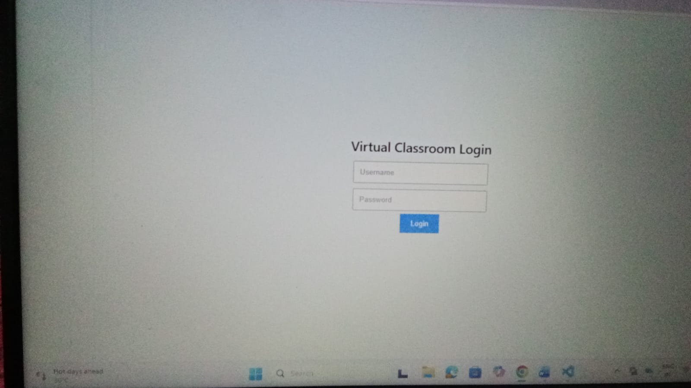
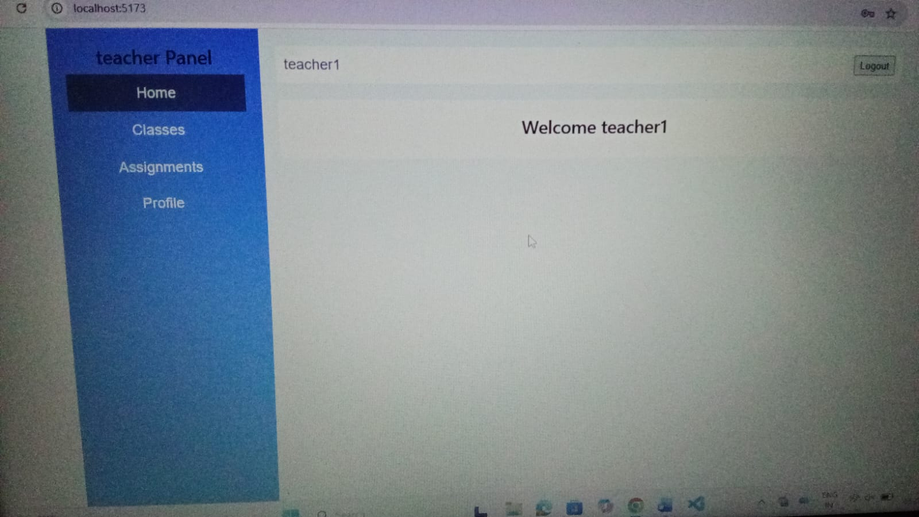
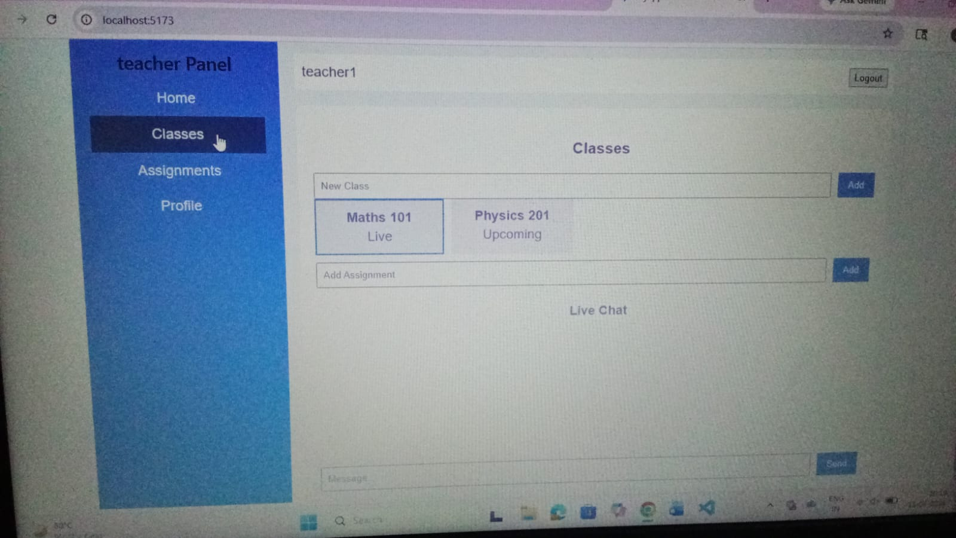
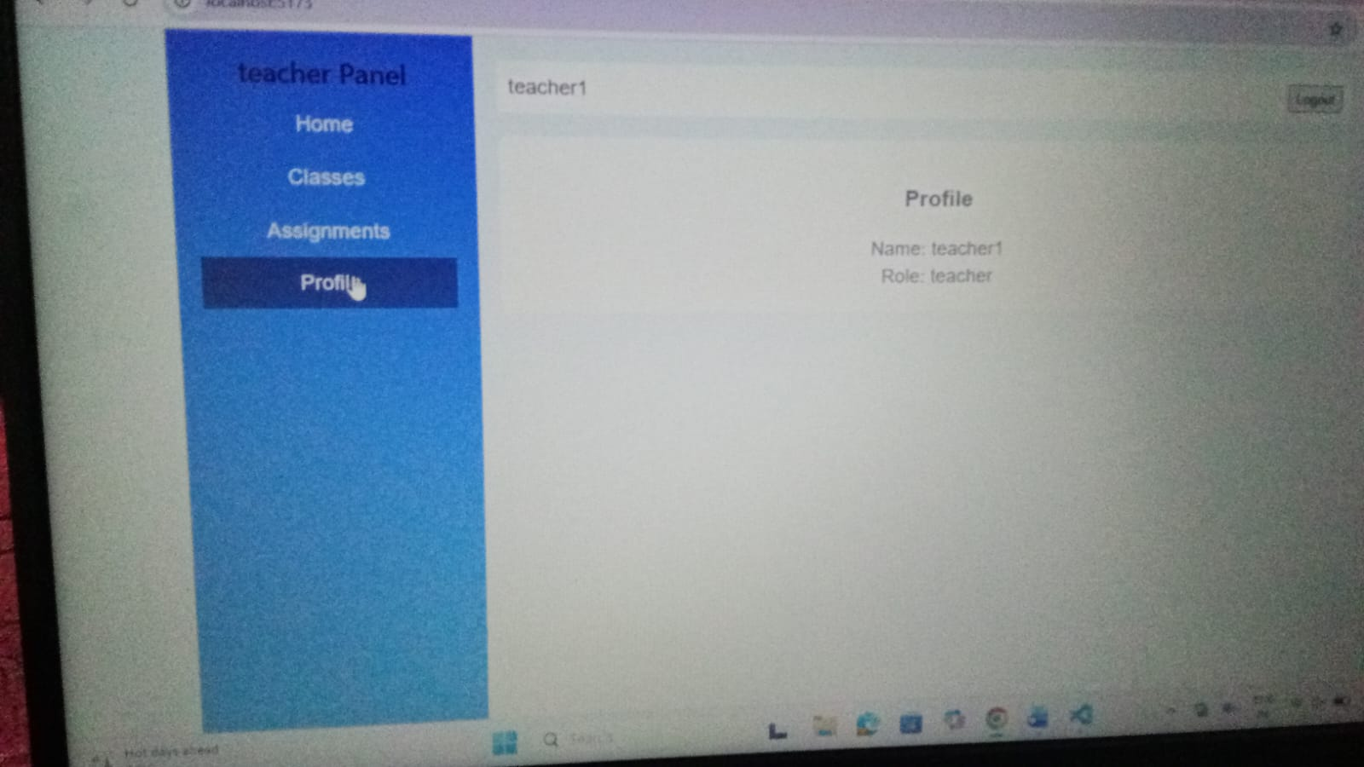
Appendix C – User Manual / Installation Guide
Steps to Run the Project:
- Download all project files such as index.html, style.css, and script.js.
- Ensure all files are placed in the same folder directory.
- Open the index.html file using any modern web browser.
- Navigate through the dashboard to view available courses and lessons.
- Attempt quizzes and view results instantly on the same page.

System Requirements:
- Operating System: Windows / macOS / Linux
- Browser: Latest version of Google Chrome, Mozilla Firefox, or Microsoft Edge
- RAM: Minimum 2 GB or higher
- Storage: At least 100 MB free space

